

Capstone Project Document
[Project name]

<Group Name>
Group Members | <Member name><RollNo><Student code >  <Member name><RollNo>< Student code >  <Member name><RollNo>< Student code >  <Member name><RollNo>< Student code >  <Member name><RollNo>< Student code >
Supervisor
Ext Supervisor
Capstone Project code

– Hanoi, Aug 2026 –

Table of Contents
Table of Contents 2
Acknowledgements 3
Definition and Acronyms 4
Chapter 1 - Introduction 5
1. Project Overview 5
2. Rationale/Background 5
3. Business Process Improvement 5
4. Related / Comparable Products 7
5. Technologies and Tools 7
6. Theoretical Foundations 8
Chapter 2 - Project Management Plan 9
1. Project Objectives 9
2. Project Scope 9
3. Process / Methodology 9
4. Assumptions & Constraints 10
5. Project Plan Summary 10
Chapter 3 - Requirements Analysis 12
1. Overall Requirements 12
2. Use Case Specifications 15
3. Functional Specifications 16
4. Non-Functional Requirements 16
5. Requirement Appendix 17
Chapter 4 - System Design 18
1. System Design 18
2. Database Design 18
3. Functional Design 19
4. NFR Design Specifications 19
5. Other Design Specifications 23
Chapter 5 – Delivery Package 24
1. Test & Quality Summary 24
2. Source & Build Artefacts 24
3. Database Artefacts 25
4. Project Documentation 25
5. Known Issues & Limitations 25
Chapter 6 - Conclusion and Future Work 27
1. Business/Organizational Evaluation 27
2. Project Conclusion 27
3. Future Work 28

Acknowledgements
[Fill team’s acknowledgements here…]
HOW TO WRITE THIS SECTION
• Keep this to one short page: thank your supervisor, lecturers, and family.
• Be specific rather than generic — mention what kind of help you received.
• Group project: write this as "we" on behalf of the team, not "I".

EXAMPLE — InventoryFlow: Acknowledgements (tone example)
"We would like to sincerely thank our supervisor, [Name], for weekly guidance on the module's plugin architecture and for pushing the team to justify every extensibility decision with a concrete multi-tenant scenario rather than a single-client assumption..."

Definition and Acronyms
[Fill all the definitions, acronyms,… used within the document] in the table format as below]
Acronym | Definition
PWM | Psychology website
AWS | Amazon Web Services
BA | Business Analysis
BR | Business Rule
ERD | Entity Relationship Diagram
GUI | Graphical User Interface
PM | Project Manager
SDD | Software Design Description
SPMP | Software Project Management Plan
SRS | Software Requirement Specification
UAT | User Acceptance Test
UC | Use Case
API | Application Program Interface

Chapter 1 - Introduction

1. Project Overview
[Provide the brief information of the project: project name, project code, group name, etc. and list out the details of the project team and stakeholders…]

2. Rationale/Background
[Explain why this project is worth building and what gap, problem, or opportunity motivated it. The below contents should be included in this section:
- The problem, gap, or opportunity you observed.
- Why existing solutions (competing products, open-source tools, manual workarounds) are insufficient.
- The trigger for the project (capstone brief, market observation, prior internship exposure, personal experience)]

HOW TO WRITE THIS SECTION
• If your project is a product or platform meant to serve many future users/clients rather than one organization, frame the motivation around a target market or user segment rather than one company's specific pain point — that distinction is what separates a Software Engineering product-style report from an Information Systems report built around one organization (see the companion Information Systems template for that version).
• Cite at least one external source (market report, competitor page, user complaints, prior research) to support that the gap is real.

EXAMPLE — InventoryFlow: Rationale
"Small and mid-size retail chains (1–10 branches) are typically priced out of full-scale ERP suites such as SAP Business One, while spreadsheet-based inventory tracking breaks down once a business operates more than 2–3 stores with shared suppliers. InventoryFlow was proposed as a lightweight, configurable inventory & procurement module that a retailer can adopt directly, or that a systems integrator can white-label for multiple clients, without a multi-month ERP implementation project."

3. Business Process Improvement

3.1 Current (As-Is) Process Analysis
[Document how the process works today, before any system change.
- As-is process model (BPMN or a similar notation) of the current process.
- Pain points/bottlenecks identified, each tied to a concrete impact.]
HOW TO WRITE THIS SECTION
• Model the process as it exists today, warts and all, before proposing anything.
• For every pain point, state a measurable or observable impact rather than a general complaint.

[Figure 1.1 — As-Is BPMN Diagram of the Patient-Visit Process (to be inserted)]

EXAMPLE — MedRecord: As-Is Process — Pain Points
Pain point | Observed impact
Manual chart retrieval by name | 6–8 minutes per returning patient during peak hours; visible backlog of 4–6 waiting patients by mid-morning on the observed day
No cross-doctor medication visibility | No mechanism to detect a drug interaction across doctors' prescriptions for the same patient
Handwritten notes | Notes occasionally illegible to a doctor other than the author

3.2 Feasibility Study
[Assess whether the proposed system is worth building, across three dimensions.
- Technical feasibility (can it be built with available skills/technology/integration points).
- Economic feasibility (rough cost vs. expected benefit, even if approximate for an academic project).
- Operational feasibility (will the organization actually adopt it — stakeholder buy-in, change resistance)]
HOW TO WRITE THIS SECTION
• Give each dimension its own short subsection.
• Operational feasibility should explicitly address staff readiness and any resistance to changing an established process — this is often the deciding factor in real-world adoption.

EXAMPLE — MedRecord: Feasibility Study
Dimension | Finding
Technical | A single on-premises server is sufficient for the clinic's data volume (~80 patients/day); no cloud infrastructure required for the pilot phase.
Economic | Estimated 25–30 staff-hours/month currently lost to manual chart retrieval and re-filing; the system is expected to reduce this to under 5 hours/month.
Operational | One of the three doctors expressed concern about typing speed during consultations; the design response was a structured note template with dropdowns/checkboxes to minimize free typing, validated with that doctor before full rollout.

3.3 Proposed (To-Be) Process Design
[Show how the process will work after the system is introduced.
- To-be process model (BPMN or similar) showing the redesigned workflow.
- Explicit comparison: which steps are eliminated, automated, or changed relative to 3.1]
HOW TO WRITE THIS SECTION
• Always pair the to-be diagram with an explicit "what changed and why" list — reviewers want to see the redesign reasoning, not just a prettier diagram.

[Figure 1.2 — To-Be BPMN Diagram of the Patient-Visit Process (to be inserted)]

EXAMPLE — MedRecord: As-Is vs. To-Be Comparison
As-Is step | To-Be change
Manual chart search by name (6–8 min) | Digital lookup by name or phone (under 30 sec)
No cross-doctor medication check | Automatic interaction check across all doctors' prescriptions for the patient
Handwritten notes, occasionally illegible | Structured note entry with dropdowns/checkboxes, always legible

4. Related / Comparable Products
[Study/Survey 2–4 comparable existing products and compare them against your project.
- Brief description of each comparable product.
- A feature-comparison table.
- The specific gap your product fills relative to these.]

HOW TO WRITE THIS SECTION
• Compare against commercial products or the broader market, not against "the current process of one organization" — that framing belongs to a single-organization project (see the companion Information Systems template).

EXAMPLE — InventoryFlow: Comparable Products
Feature | SAP Business One | Zoho Inventory | InventoryFlow
Multi-tenant white-label support | No (single-org deployment) | No | Yes
Configurable reorder engine (EOQ) | Yes (complex config) | Basic reorder point only | Yes, per-SKU EOQ + safety stock
Typical setup time | Weeks to months | Days | Hours to days
Price tier | Enterprise | SMB subscription | SMB / white-label
Target segment | Large enterprise | Individual SMB | SMB and integrators serving SMBs

The comparison shows a gap: SAP Business One is generally too costly and complex for a single-digit-branch retailer, while Zoho Inventory, though lightweight, does not support white-labeling for a systems integrator serving several independent retail clients from one codebase.

5. Technologies and Tools
[Introduce each major technology/framework used and justify the choice
- Backend framework, frontend approach, database, any domain-specific libraries.
- For each: what it is, why chosen, one alternative considered.]

HOW TO WRITE THIS SECTION
• Group technologies under sub-headings (API layer, data layer, background jobs,..) rather than a flat list.
• Justify each choice against a real requirement or constraint from your own project, not a generic "it's popular" reason.

EXAMPLE — InventoryFlow: Technologies and Tools
"Spring Boot was chosen for the API layer for its mature multi-tenancy support via schema-per-tenant routing, which directly maps to InventoryFlow's requirement that each retailer's data stay isolated. PostgreSQL was chosen over a NoSQL store because purchase-order and reorder logic depend heavily on relational integrity (foreign keys between SKU, Supplier, and PurchaseOrder tables)."

6. Theoretical Foundations
[Explain algorithms, models, or design theories the system relies on.
- Any domain-specific theory or algorithm used (e.g., a scheduling algorithm, a scoring model, a calculation method).
- Architectural patterns referenced (e.g., a specific data-isolation strategy, layered architecture, a design pattern).]

HOW TO WRITE THIS SECTION
• Keep this at "just enough to understand Chapter 3" depth — this is not a literature review chapter, it is grounding for your own design.
• Cite the original source for any named algorithm or pattern.

EXAMPLE — InventoryFlow: Theoretical Foundations
"Reorder suggestions are computed using the classic Economic Order Quantity (EOQ) formula, parameterized per SKU by holding cost, order cost, and historical demand rate; a configurable safety-stock buffer is added on top to account for lead-time variability, since a single fixed formula does not fit every tenant's supplier lead times."

Chapter 2 - Project Management Plan

1. Project Objectives
[State what the finished system must achieve, in measurable terms. What to include:
- General objective (one sentence).
- Specific objectives (3–6 bullet points, each verifiable).]

HOW TO WRITE THIS SECTION
• If your project is a configurable product or platform, at least one objective should address configurability/extensibility for multiple future clients or use cases — a concern that has no equivalent in a single-organization project.
• Each objective should be something you can later say "achieved / partially achieved / not achieved" about in your conclusion — avoid vague verbs like "improve" or "support" without a measurable target attached.

EXAMPLE — InventoryFlow: Objectives
General: Build a configurable inventory & procurement module that a retail SME can deploy standalone or a systems integrator can white-label for multiple clients.
Specific objectives:
1. Support multi-tenant configuration (each tenant defines its own SKU attributes, reorder rules, and supplier list) without code changes.
2. Implement an automatic reorder-point engine using configurable Economic Order Quantity (EOQ) parameters per SKU.
3. Expose a REST API so the module can be embedded into a tenant's existing POS or e-commerce stack.
4. Achieve functional test pass rate ≥ 95% across at least two distinct tenant configuration profiles.

2. Project Scope
[Define the system's feature boundary. What to include
- In-scope features / modules.
- Out-of-scope items.
- Target users and target scale (expected number of users, records, or transaction volume).]

HOW TO WRITE THIS SECTION
• Scope a product-style project by feature set and target user segment; scope a single-organization project by which departments/processes are covered (see the companion Information Systems template for that framing).

EXAMPLE — InventoryFlow: Scope
In scope: SKU/catalog management, supplier management, purchase-order generation, automatic reorder suggestions, multi-tenant configuration, REST API.
Out of scope: point-of-sale (POS) transaction processing, accounting/GL integration, HR/payroll.
Target scale: designed for tenants with up to 50,000 SKUs and 20 concurrent purchasing staff per tenant.

3. Process / Methodology
[Describe the process model and tools used. What to include:
- SDLC/process model followed and why it fits the project.
- Tools used for management, version control, and communication.
- Group project: how work was divided among members and how integration points between members' modules were coordinated.]

HOW TO WRITE THIS SECTION
• Justify the process model against the actual concerns of your project (e.g., needing a stable interface while iterating on other parts, or needing frequent stakeholder feedback), not just naming a methodology.
• Group project: add a short "Team organization" subsection stating who owned which area and how cross-member integration points were handled — this is what lets the committee understand the Contribution Statement's percentages, not just take them on faith.

EXAMPLE — InventoryFlow: Methodology
"The project followed an Agile/Scrum process with two-week sprints, executed by a three-member team. Because the core API had to remain stable for future integrators, API contracts were designed and reviewed by at least one other member before implementation each sprint, using OpenAPI specs as a design-first artifact rather than generating them after the fact. Git was used with mandatory pull-request review by a second member before merging."
Team organization: "The team leader owned the reorder engine and data layer; the second member owned the public API and tenant-isolation logic; the third member owned the UI and led test-case execution across modules. Cross-module integration points were paired between the responsible members rather than handed off asynchronously."

4. Assumptions & Constraints
- Assumptions: ......................................................................
- Constraints (technology, timeline, budget...): ......................................................................

5. Project Plan Summary
[Show the project's schedule at milestone level and how actual progress compared to what was planned. What to include
- A milestone table: Milestone | Planned week | Actual week | Owner(s).
- A short explanation of any significant slip — what caused it and how the team absorbed it.
- A short risk log identified during planning, with likelihood and mitigation.
- Full WBS and a detailed sprint-by-sprint log belong in an appendix, not here — this section is a one-page summary.]

HOW TO WRITE THIS SECTION
• Always include at least one real slip with an honest explanation rather than presenting a plan that matched reality perfectly — committees read a frictionless timeline as unconvincing, and explaining how the team absorbed a real slip is more persuasive than a clean Gantt chart.
• Tie each slip and each risk-mitigation action back to a specific member or the whole team

5.1 Project Schedule
EXAMPLE — InventoryFlow: Project Plan Summary — Milestone Table
Milestone | Planned week | Actual week | Owner(s)
Requirements & SRS sign-off | Week 2 | Week 2 | All members
Database design & API contract review | Week 4 | Week 5 | [Member 1], [Member 2]
Core module implementation complete | Week 10 | Week 12 | All members
System testing complete | Week 13 | Week 14 | [Member 3]
Pilot / final validation | Week 15 | Week 15 | All members
"The two-week slip on core implementation was caused by the tenant-isolation redesign described in Section 4.3 (Challenge 2): once the query-layer interceptor was identified as necessary, [Member 2] had to rework API-layer data-access code already written by that point. The team absorbed this by compressing the buffer originally planned before system testing rather than delaying the pilot."

5.2 Risk and Mitigations
EXAMPLE — InventoryFlow: Project Plan Summary — Risk Log
Risk | Probability | Impact | Mitigation
Multi-tenant isolation bug discovered late | Medium | High | Added the query-interceptor design review checkpoint after Sprint 2 rather than only at final testing.
Nightly job performance not tested at realistic scale until late | Medium | High | Seeded a 100-tenant dataset from Sprint 4 onward instead of waiting until system testing.
Uneven workload across 3 members | Low | Medium | Weekly sync meetings used to rebalance tasks; tracked against the Contribution Statement.

5.3 Responsibility Assignments
[Provide the project organization structure and describe the main project responsibilities in the similar way as sample below]
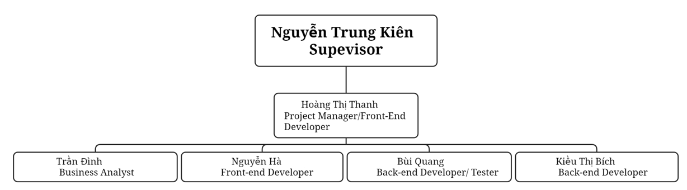
RACI Chart: R~Responsible, A~Accountable, C~Consulted, I~Informed
Work Package | ThanhHTHE014079 | DinhTHE03580 | HaNHE03235 | QuangBHE04871 | BichKTHE04278
Work Package Name1 | R | A | C | I | R
Work Package Name2 | I | A | R | R | C
…

Chapter 3 - Requirements Analysis

1. Overall Requirements

1.1. Context Diagram
[Provides the overall description about the product with some introduction and the context diagram]
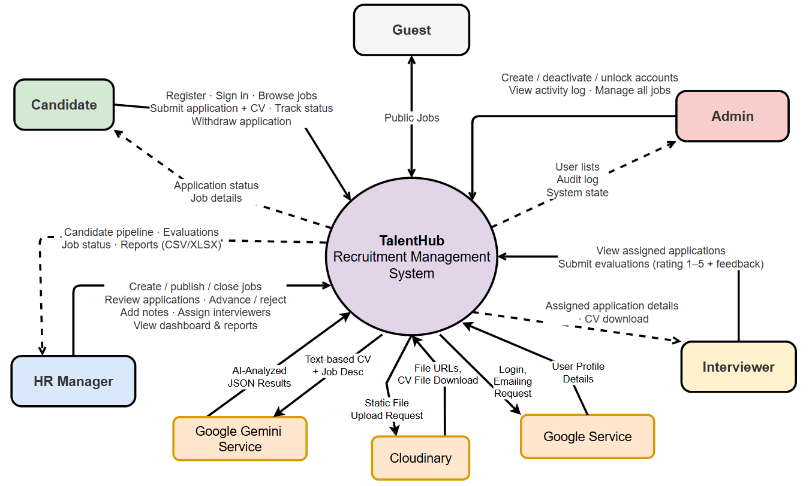

1.2. Main Business Flows
[List all flows with swimlane diagrams as samples below].

1.2.1 Candidate Self-Service (BF-01)
Trigger: Candidate creates an account.
End condition: Candidate has seen the final outcome of all applications.
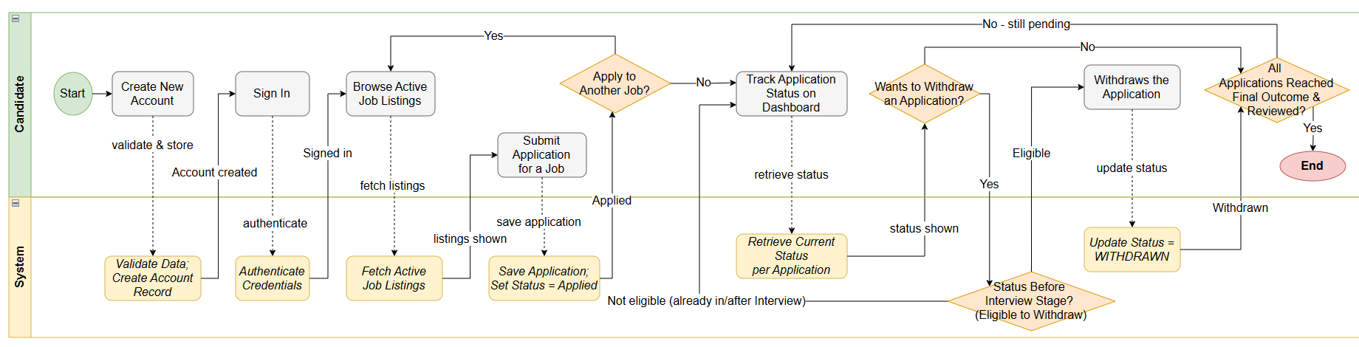

1.2.2 Business Flow Name (Code)
…

1.2.3 …

1.3. Entity Relationship Diagram
[Provide the ERD using the Crow-Foot notation and the entity descriptions as below. Relationship labels are business verb-ing]
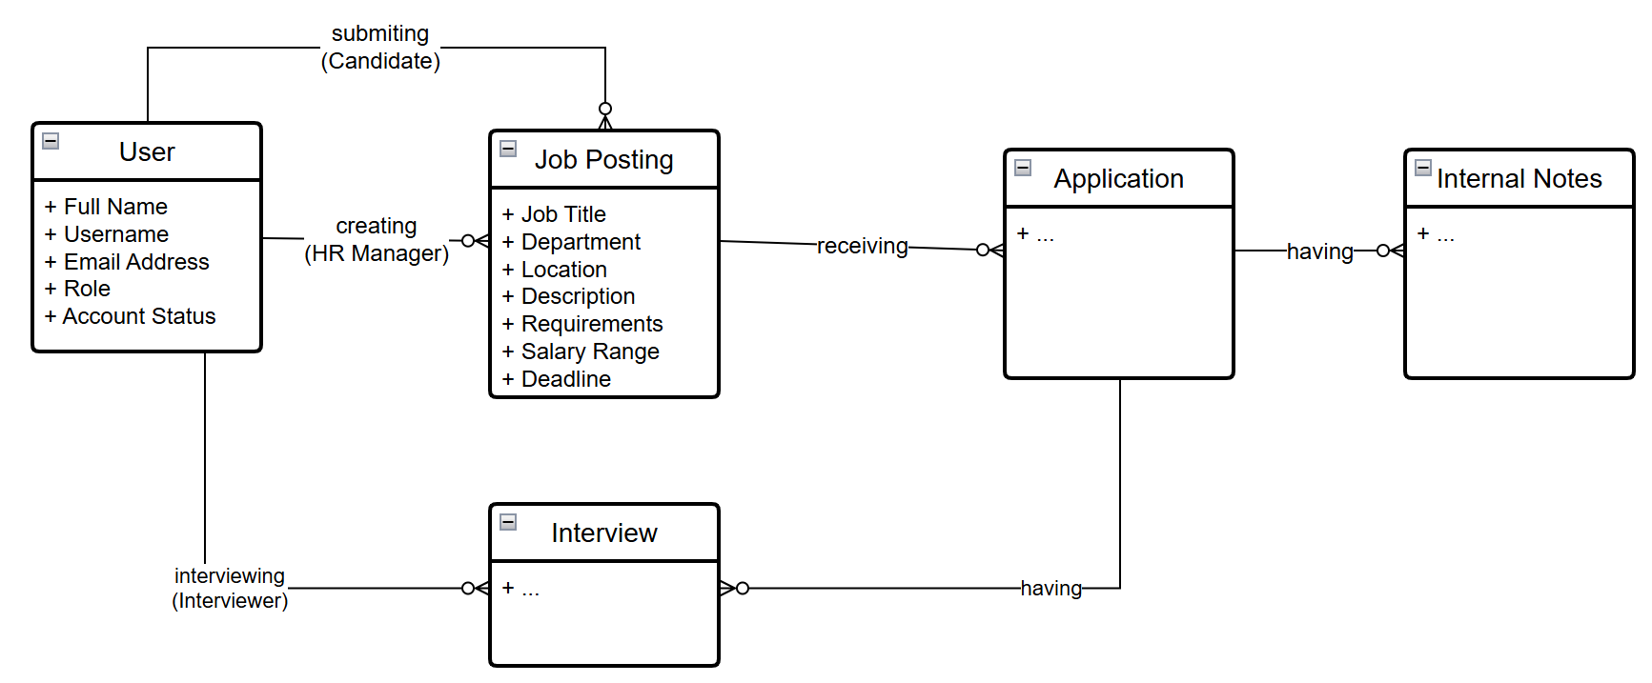
Entity Purposes
Entity | Purpose
User | {{Purpose of the User Entity}}
Job Posting | …

1.4. User Requirements

1.4.1 System Actors
[This part gives the description of system actors, you can follow the table form as below]
Actor | Description
Tenant Admin | Configures tenant-level settings: SKU attributes, reorder rules, supplier list, and user accounts within the tenant.
Purchasing Staff | Reviews and submits draft purchase orders; manages day-to-day SKU and supplier data.
Supplier (external) | Receives purchase orders via the API integration; not a direct system user.
Platform Admin | Manages tenant onboarding and platform-level configuration; not scoped to any single tenant's data.

1.4.2 Use Case Diagrams

a. UCs for Guest
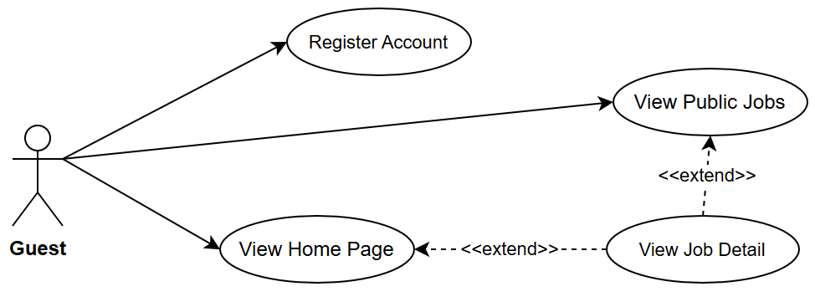

b. UCs for Candidate
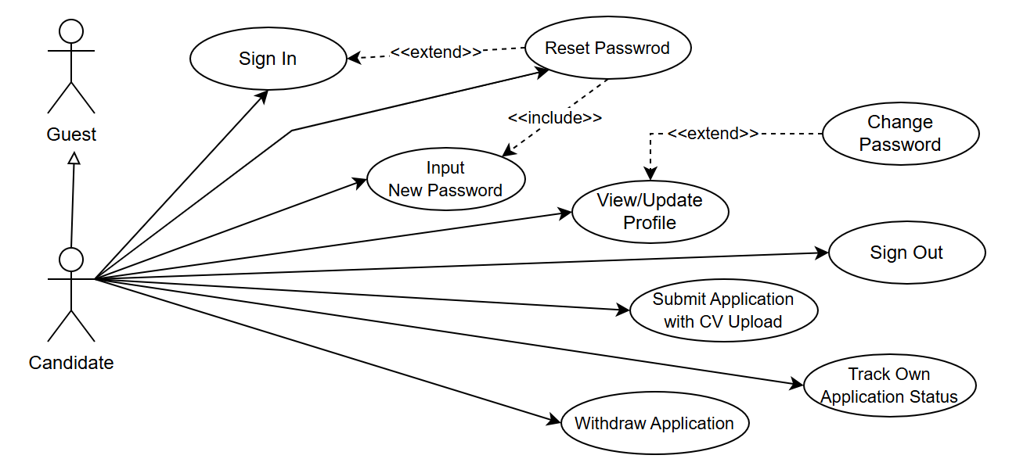

c. …

1.4.3 Use Case Inventory
[This part describes the use cases following the form of the table as below]
ID | Use Case | Feature | Use Case Description
01 | View Menu | Feature Name1
02 | Order a Meal | Feature Name2
03 | …
…

1.5. System Functionalities
[Provide functionality overview of software system]

1.5.1 Screen Inventory

a. Screen Flow
[This part shows the system screens and the relationship among screens – see sample below]
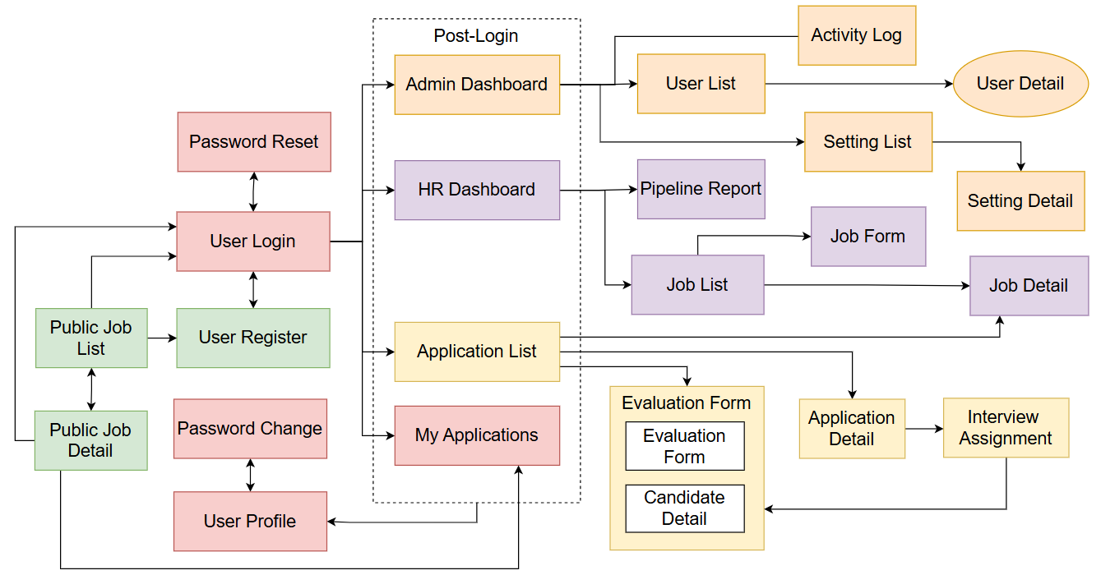

b. Descriptions
[Fill details of each screen into the table with the columns and sample data as below]
# | Screen Name | Feature | Description
1 | Sign In | Authentication | Allows any user to authenticate and reach their role-specific area of the system
2 | User Register | Authentication | Allows a new Candidate to create their own account
3 | …

1.5.2 External API Inventory
[Fill details of each external API into the table with the columns and sample data as below]
# | API Name | Calling Path | Description
1 | Employee sync API | HRM System → TalentHub | allows an external HR management system to push employee records and automatically create Interviewer accounts
2 | Outbound webhook | TalentHub → External HRM | notifies an external system when a Candidate's status changes to HIRED
3 | ..

1.5.3 Background Job Inventory
[Fill details of each background job into the table with the columns and sample data as below]
# | Job Name | Group | Description
1 | Unlock expired locked accounts | Scheduled | Every 15 minutes
2 | Clean up old audit log entries | Scheduled | Daily at 2:00 AM

2. Use Case Specifications
[Pick 5-8 most important/complext use case from the main business flows and provide specifications for them in the table form as sample below]

2.1 EXAMPLE – Login System
Primary Actors | Customer | Secondary Actors | None
Description | As a user, I want to be able to log into the system so that I can use the system’s authenticated features and access my personalized account.
Preconditions | User account has been created & authorized
Normal Flow | Login System  - User clicks Login button from the page header or accesses an authenticated feature (from a link or type the page URL directly into the address bar)  - System show the User Login screen  - User types in the login details (email, password)  - User clicks the Login button  - System validates the login details (GBR-04, GBR-05)  - System allows user to access  - System tracks user’s success login to the Activity Log  - System directs user to the Home Page (or the previous calling page if any)
Alternative Flows | Step 2.1_Google Login  - User clicks Google Login button to login system using Google account  - System redirects the user to the Google’s Login screen  - User types in the Google account details and chooses to login  - Google validates user’s login information successfully and redirect him/her back to the system  - Return to step 5 of normal flow.  Step 4_System can’t authenticate the user  User can’t be authenticated & get relevant error message in one of below cases  - He/she leaves the Email and/or Password field blank (MSG10)  - Input Email or Password are incorrect (MSG09)  - Input Email/Password are correct but email has not been verified (MSG11)  - The user account is blocked / inactive (MSG12)  If user inputs wrong logging-in details 5 times continuously, system will lock his/her account in 30 minutes (with relevant warning message - MSG13)
Postconditions | - User logs in the system successfully  - The system tracked successful login into the Activity Log

2.2 Use Case Name2
…

3. Functional Specifications
[Show what the system will look like before implementation. What to include:
- Wireframes or mockups for the key screens per role.
- Rationale for layout/navigation decisions.]
How to write this section?
- Include only the screens that matter for understanding the system; an exhaustive screen-by-screen catalog belongs in an appendix, not the main body.
- If your system is configurable for multiple clients, include a configuration/settings screen as one of the key screens shown — that screen type is worth featuring since it doesn't exist in a single-purpose system.]

3.1 Screen Name1
[Content #1: UI layout (Wireframe or Mockup for the screen]
[Content #2: brief descriptions of the screen/function, mapped to the relevant use cases]
- Use Case Name1: UC1 Description
- Use Case Name2: UC2 Description
[Content #3: provide further descriptions for the screen’s components/fields using table format below]
Field Name | Description
Field Name1 | Field description: data type min/max length or value, initial data, etc.
Field Name2 | …
Field Group-Name1
Field Name3 | …
Field Name4 | …
Field Group-Name2
… | …

3.2 Screen Name2
…

4. Non-Functional Requirements

4.1 External Interfaces
[This section provides information to ensure that the system will communicate properly with users and with external hardware or software elements.]

4.2 Quality Attributes
[List all the required system characteristics (quality attributes) specification. Some of the possible attributes are provided with the guide/descriptions are mentioned here]

4.2.1 Performance
[The system’s performance characteristics are outlined in this section. Some samples are as below]
Requirement | Target | Condition
Page load time | Any page loads within 2 seconds | Up to 100 users active simultaneously
Form submission response | System acknowledges within 2 seconds | Up to 100 users active simultaneously
Maximum simultaneous users | System remains fully functional for up to 100 users | Single server deployment

4.2.2 Security
[State the requirement of security, not the implementation mechanism. Some samples are as below]
Requirement | Description
Authentication required | Every page and action other than the sign-in page, registration page, and public job listings requires the user to be signed in.
Password protection | Passwords must never be stored in a form that a person or program can read.
CV file access | CV files may only be accessed by users with permission to view the associated Application. The system verifies permission on every access.

4.2.3 Attribute NameX
…

5. Requirement Appendix
[Provide business rules, common requirements, or other extra requirements information here]

5.1 Business Rules
[Provide common business rules that you must follow. The information can be provided in the table format as the sample below]
GBR-ID | Rule Statement | Applies To | Rationale | Enforced By
GB-01 | Status changes are one-way and permanent. No status may be reverted to a previous value. | Job posting status, Application status, Interview status | Prevents data integrity loss; maintains clear audit trail. | The system automatically on every status change
GB-02 | Internal Notes are never visible to Candidates, regardless of how they access the system. | All views accessible to Candidates | Allows HR to write candid internal assessments. | The system automatically on every page and data request
GB-03 | When a sign-in fails, the message must not reveal whether the username exists or the password was wrong. | Sign-in | Prevents attackers from discovering valid usernames. | The system automatically on every failed sign-in

5.2 System Messages
# | Message code | Message Type | Context | Content
1 | MSG01 | In line | There is not any search result | No search results.
2 | MSG02 | In red, under the text box | Input-required fields are empty | The * field is required.
3 | MSG03 | Toast message | Updating asset(s) information successfully | Update asset(s) successfully.
8 | ..

5.3 Other Requirements
…

Chapter 4 - System Design
[Provide software design specifications in this chapter, details as described in each section]

1. System Design

1.1 System Architecture
[The content of this section includes the overall diagram which includes the sub-systems, the external systems, and the relationship/connection among them]
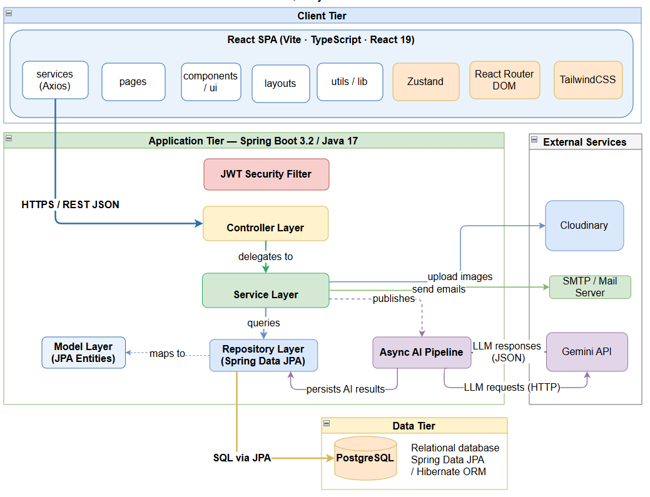

1.2 Package Diagram
[Provide the overall package diagram for each sub-system]
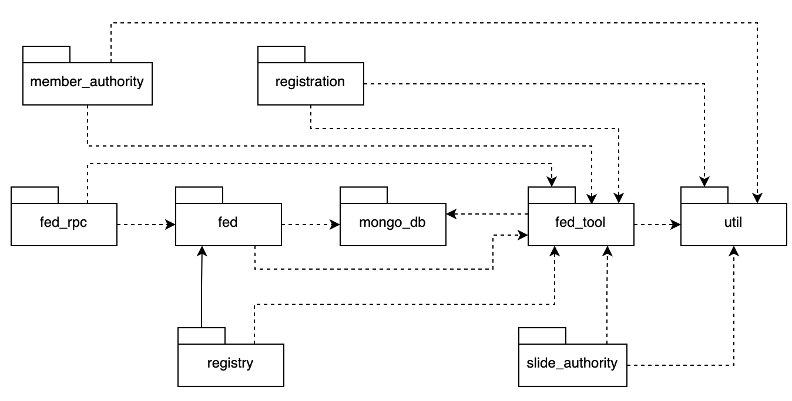

2. Database Design
[Provide the files description, database table relationship & table descriptions like example below]
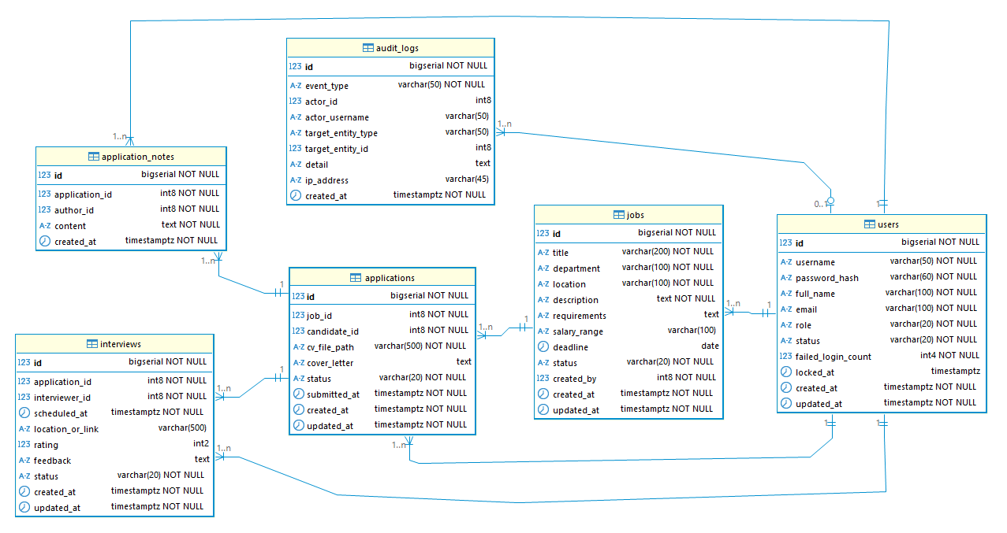
Table | Key design decision
`[table-1]` | [e.g. 'Single entity covering all roles — role stored as VARCHAR with CHECK constraint']
`[table-2]` | [e.g. 'Status transitions enforced by DB trigger — rejects invalid UPDATEs at DB level']
`[table-3]` | [e.g. 'Unique composite index on (a, b) — enforces business uniqueness rule at DB level, even after withdrawal']
`[table-4]` | [e.g. 'Insert-only — PostgreSQL RULE blocks UPDATE and DELETE. Records immutable at DB level.']
`[table-5]` | [e.g. 'Insert-only audit log — high-severity events retained indefinitely; low-severity cleaned up after N days by scheduler']

3. Functional Design
[Provide the detailed design for the key feature of the system. It includes Class Diagram, and one or more Sequence Diagram(s)]

3.1 Class Diagram
[This part presents the class diagram for the relevant feature]

3.2 Sequence Diagram(s)

3.2.1 <Use Case Name1>
[Provide the sequence diagram(s) for the first use case of the feature]

3.2.2 <Sequence Diagram Name2>

3.2.3 …

4. NFR Design Specifications
[Provide design specifications for non functional requirements in the similar way as samples below]

4.1 Security Design

4.1.1 Authentication Flow
TalentHub v2 uses stateless JWT-based authentication. The React SPA stores tokens in memory (not localStorage) to mitigate XSS. A refresh token is stored in an HttpOnly cookie. The Spring Security filter chain validates the access token on every protected request.

a. Token Design
Aspect | Design Decision
Token format | JWT — RS256 (asymmetric — private key signs, public key verifies)
Access token expiry | 15 minutes — short window limits exposure if intercepted
Refresh token expiry | 7 days — stored as HttpOnly, SameSite=Strict, Secure cookie
Access token storage (client) | React memory only (AuthProvider useState) — never localStorage or sessionStorage
Refresh token storage (client) | HttpOnly cookie — JS cannot read it; sent automatically by browser on refresh requests
Token blacklist strategy | Redis SET with TTL = remaining refresh token validity; checked on every refresh attempt
Claims in access token | `sub` (user_id UUID), `role` (user_role enum), `iat`, `exp`, `jti` (unique token ID for blacklisting)
Signing key | RSA 2048-bit key pair — private key in env var; public key exposed at /api/v1/auth/public-key for verification
Refresh endpoint | POST /api/v1/auth/refresh — reads HttpOnly cookie; validates refresh token not blacklisted; returns new access token
Logout | POST /api/v1/auth/logout — adds refresh token jti to Redis blacklist; clears cookie

b. CORS Configuration
CORS is required because the React SPA (e.g. https://app.shopeasy.vn) and the Spring Boot API (e.g. https://api.talenthub.vn) run on different origins in production.
Environment | Allowed Origins | Allowed Methods | Allow Credentials | Max Age
Development | http://localhost:5173 | GET, POST, PUT, PATCH, DELETE, OPTIONS | true (needed for HttpOnly cookie) | 3600s
Staging | https://staging.talenthub.vn | GET, POST, PUT, PATCH, DELETE, OPTIONS | TRUE | 3600s
Production | https://app.talenthub.vn | GET, POST, PUT, PATCH, DELETE, OPTIONS | TRUE | 86400s

CORS security rule
allowCredentials = true REQUIRES an explicit origin (not wildcard *).
Wildcard (*) with credentials is rejected by all browsers as a security violation.
Never use allowedOrigins('*') when allowCredentials is true.

JWT RS256 with 15-minute access tokens and 7-day HttpOnly cookie refresh tokens. Spring Security stateless filter chain validates access token on every protected request.

4.1.2 Authorization & RBAC Implementation
Aspect | Decision
RBAC implementation | Spring Security @PreAuthorize('hasRole(...)') on @RestController methods; SecurityConfig configures /api/v1/auth/** as public; all /api/v1/** requires authenticated
Role storage | users.role column (user_role ENUM); loaded into UserDetails on login; embedded as claim in JWT access token
Role hierarchy | ADMIN > MANAGER > WAREHOUSE > CUSTOMER — Spring Security RoleHierarchyImpl configured in SecurityConfig
Frontend enforcement | ProtectedRoute wrapper checks user.role from AuthProvider; Admin-only routes redirect non-Admin to /403
Data-level filtering | Repository queries filter by shop/role — same as v1; JWT claim provides user_id and role without DB lookup on each request
Failed auth — API | HTTP 401 → JSON AUTH_001 (no redirect — SPA handles navigation)
Failed auth — Frontend | Axios 401 interceptor → refresh attempt → if refresh fails → redirect to /login

4.1.3 Data Protection
Data Category | At Rest | In Transit | Notes
All traffic | N/A | TLS 1.2+ (NFR-SEC01) | Nginx terminates TLS; API container on private network
Passwords | bcrypt cost 12 (NFR-SEC02) | TLS | Never logged; never returned in API responses
PII | DB disk encryption (managed service) | TLS | Soft-delete + anonymisation for NĐ 13/2023 (NFR-C02)
Payment data | Not stored (NFR-SEC03) | TLS | VNPay/MoMo handle capture; ShopEasy stores event_id + result only
JWT access token | React memory (in-memory store) | TLS | Never in localStorage; never in cookie
JWT refresh token | HttpOnly cookie (browser) | TLS | SameSite=Strict, Secure; JS cannot read
API keys (external) | Environment variables / cloud secrets | TLS | Never in source code; never logged

4.1.4 Input Validation Strategy
Layer | Validation | Implementation
React — form | Client-side schema validation before API call | React Hook Form + Zod schemas mirroring backend DTO constraints; immediate inline feedback
Spring Boot — DTO | Bean validation on @RequestBody | @Valid + Jakarta Validation (@NotBlank, @Size, @Min, @Max); BindingResult surfaced as 400 + field error
Spring Boot — service | Business constraint validation | Same BR checks as v1 (BR-04 max pending, DC-01 state transition, BV-02b quantity)
Spring Boot — DB | Data integrity last line of defence | UNIQUE, CHECK, NOT NULL constraints; DataIntegrityViolationException → 409
SQL injection | JPA parameterised queries only | No native string concatenation; @Query uses named parameters
XSS — API | JSON responses; no HTML rendering | Spring Boot returns JSON only; XSS via API response is not applicable
XSS — React | React auto-escapes JSX expressions | Never use dangerouslySetInnerHTML; CSP header from Nginx

4.1.5 Security Headers & CORS Policy
Security headers are applied by Nginx (not Spring Boot) since Nginx is the public entry point in v2.
Header | Value | Applied By
Strict-Transport-Security | max-age=31536000; includeSubDomains | Nginx
X-Content-Type-Options | nosniff | Nginx
X-Frame-Options | DENY | Nginx
Content-Security-Policy | default-src 'self'; script-src 'self'; style-src 'self' 'unsafe-inline'; connect-src 'self' https://api.shopeasy.vn | Nginx
Referrer-Policy | strict-origin-when-cross-origin | Nginx
X-Correlation-ID | UUID generated per request | Spring Boot filter
Access-Control-Allow-Origin | Explicit origin only (see Part 2.2 CORS table) | Spring Boot SecurityConfig

4.2 Performance & Scalability Design

4.2.1 Caching Strategy
v2 migrates from Caffeine (in-process) to Redis for all caching. This is required because the React SPA polls the API every 60 seconds from potentially multiple browser tabs/instances, and multi-instance API deployment requires a shared cache.
What is Cached | Redis Key | TTL | Invalidation Trigger | NFR
Application list (per filter combo) | cache:application:  list:{hash} | 30s | On any application status change in that shop | NFR-P01 — avoids DB hit on 60s polling
Job detail | cache:job:{job_id} | 10 min | On JOB threshold update or re-activation | NFR-P01
Recruitment report aggregate | cache:report:  recruitment:  {params_hash} | 30 min | On Admin manual cache clear | NFR-P04
Channel config | cache:channel:  {channel_type} | 60 min | On Admin channel config update | NFR-P01 — avoids DB on every poll cycle
User role (for JWT claims) | Not cached — embedded in JWT | — | JWT expiry (15 min) | NFR-P01 — no DB lookup per request
Frontend caching — TanStack Query:
Query | staleTime | gcTime | Notes
Application list | 30s | 5 min | Background refetch every 60s keeps inbox fresh (AC-01)
Application detail | 60s | 10 min | Refetches after lock mutation (optimistic update)
Company list | 2 min | 10 min | Low-stock alerts update on next refetch cycle
Company report | 5 min | 30 min | User manually triggers date range change
User profile (auth/me) | 15 min | 30 min | Rarely changes; refetch on window focus only

4.2.2 Database Query Optimization
Identical to v1 — same indexes, same N+1 prevention patterns, same pagination strategy. See TDS v1.0.0 Part 7.2.
v2 note — additional optimisation for JWT-less DB lookup:
- User role and ID are embedded in the JWT access token — no DB lookup required on each API request to verify role.
- Only the /auth/me endpoint (and user deactivation check) hits the users table — all other endpoints use JWT claims directly.

4.2.3 Scaling Approach
NFR | v2 Approach | v2 Improvement over v1
NFR-S01: >= 1,000 concurrent users | Multiple API instances behind load balancer; React served from CDN (zero API load for static assets) | Static assets on CDN remove load from API tier entirely; stateless JWT eliminates shared session store problem
NFR-S02: No code changes for scaling | Stateless JWT auth; Redis shared cache; no in-process state | JWT eliminates the main scaling constraint of v1 (in-process session store)
NFR-S03: >= 500,000 Order records | Same index strategy as v1 | No change required

4.3 …

5. Other Design Specifications
[Provide any other design specifications here: data design, system integrations, algorithms, etc.]
…

Chapter 5 – Delivery Package
[Provide delivery package details as below samples]

1. Test & Quality Summary
[Fill below tables with test result statistics]

1.1 Test Results
Document | Total | UT | IT | ST | AT |  | Notes
Round #1
Passed
Failed
Pending
Round #2
Passed
Failed
Pending
Round #3
Passed
Failed
Pending

1.2 Test Levels’ Defects
Metric | Review | UT | IT | ST | AT | Total | Note
Total Defects | - | - | - | - | - | -
Open Defects (Critical) | - | - | - | - | - | -
Open Defects (Major) | - | - | - | - | - | -

1.3 Work Product’s Defects
Product | Review | UT | IT | ST | AT | Total | Note
Software Package | - | - | - | - | - | -
Report 1 (Intro) | - | - | - | - | - | -
Report 2 (Plan) | - | - | - | - | - | -
…

1.4 User Acceptance Tests (UAT)
Script ID | Title | Business Flow | Status
SC-01 | [UAT script title — plain language] | BF-[NN] | Passed
SC-02 | [UAT script title] | BF-[NN] | Failed
SC-03 | [UAT script title] | BF-[NN] | Pending
Full UAT scripts are in: [ProjectName]_UAT_Scripts_AT.xlsx.

2. Source & Build Artefacts
Item | Location / Format | Notes
Application source code | Git repository: [repository URL] | Branch: main · Tag: v[X.X.0]
Production build artefact | [artifact-name-X.X.jar / binary] | Built by: [build command]
Build tool wrapper | [mvnw / gradlew] in repository root | [No separate installation needed]

3. Database Artefacts
Item | File | Description
Production schema | [V1__init_schema.sql] | [N tables, indexes, triggers. Applied by Flyway on first startup.]
[Seed / reference data] | [V2__seed_data.sql] | [Description — dev/staging profile only]

4. Project Documentation

4.1 SDLC Documentation
Document | File | Description
Project Introduction | [Report-1_Project Introduction.docx]
Project Planning | [Report-2_Project Management Plan]
Project Tracking | [Report-2_Project Tracking.xlsx]
Software Requirement Specifications | [Report-3_Software Requirement Specification.docx]
Software Design Specifications | [Report-4_Software Design Specification.docx]
Test Documentation | [Report-5.0_Test Documentation.docx]
User Guides | [Report-6_Software User Guides.docx]
Final Project Report | [Report-7_Final Project Report.docx] | This document

4.2 Test Artefacts
Item | File | Description
Unit Test | [ProjectName_UnitTests.xlsx] | [N] service class sheets with test cases
Integration Test | [ProjectName_IntegrationTests.xlsx] | [N] feature sheets + security tests
System Test | [ProjectName_SystemTests.xlsx] | Multi-step flow tests + scheduler tests

5. Known Issues & Limitations

5.1 Open Defects Accepted for Release
If none: write 'None — all Critical and Major defects found during testing have been fixed and verified.'
Defect ID | Title | Severity | Description | Workaround
[DEF-xxx] | [Short descriptive title] | Major | [Clear reproduction steps + expected vs actual] | [Workaround if any]

5.2 Known Limitations
Limitation | Detail | Mitigation
[Limitation 1 — e.g. 'No email notifications'] | [e.g. 'All communication is in-system only. Users must sign in to check their status.'] | [e.g. 'Communicate this to users in onboarding materials.']
[Limitation 2 — e.g. 'Session storage in-memory'] | [e.g. 'If the application restarts, all active sessions are lost — users must sign in again.'] | [e.g. 'Schedule maintenance restarts outside business hours. Inform users before planned restarts.']
[Limitation 3 — e.g. 'Single-server deployment'] | [e.g. 'Designed for a single server, no horizontal scaling.'] | [e.g. 'Sized for ≤N users. Scale vertically if needed before v2.']
[Limitation 4 — e.g. 'Migration rollback'] | [e.g. 'Rolling back a deployment with a schema migration requires a full DB restore.'] | [e.g. 'Test schema changes in staging. Maintain daily DB backups (Deployment Guide §11).']
[Limitation 5 — e.g. 'Files not encrypted at rest'] | [e.g. 'Files stored on server filesystem without application-level encryption.'] | [e.g. 'Enable full-disk encryption at OS/volume level if required by data protection policy.']
[…]

Chapter 6 - Conclusion and Future Work

1. Business/Organizational Evaluation
Assess whether the system actually improves the business process, not just whether the code works.
What to include
- Comparison of key process metrics: as-is (Section 3.1) vs. with the new system (measured or estimated during a pilot).
- Staff/stakeholder feedback on adoption (e.g., a short survey or interview).
HOW TO WRITE THIS SECTION
• This section show the pilot's real impact on the organization's operations, even if only measured over a short pilot period rather than months of production use.
• Group project: name who coordinated pilot logistics with the organization — this is often a distinct responsibility from who wrote the code, and worth crediting explicitly.

EXAMPLE — MedRecord: Business Evaluation — As-Is vs. Pilot Result
Metric | As-Is (Section 3.1) | Pilot result
Record retrieval time | 6–8 minutes (peak hours) | Under 30 seconds
Observed queue backlog (mid-morning) | 4–6 waiting patients | Noticeably shorter, per staff report
Cross-doctor interaction catches | None possible (paper process) | 1 real case caught during the pilot week
"During a one-week pilot with one doctor and both front-desk staff, coordinated by [Member 3], front-desk staff reported the queue backlog during peak hours was noticeably shorter; the pilot doctor reported the interaction alert caught one real near-duplicate prescription during the pilot week."

2. Project Conclusion

2.1 Achievements
Assess results against the project objectives as mentioned in the Chapter 2, covering both organizational/operational and system outcomes.
What to include
- Checklist mapping each objective to achieved/partially achieved/not achieved.
HOW TO WRITE THIS SECTION
• Report on the operational objectives with the same rigor as system-capability objectives.
• Mirror the exact wording of your project objectives here so the comparison is unambiguous.

EXAMPLE — MedRecord: Achievements
Project Objectives | Status | Evidence
1. Reduce retrieval time to under 30 seconds | Achieved in pilot | Section 1 (chapter 6) pilot measurement; full 3-doctor rollout not yet measured.
2. Cross-doctor interaction alert | Achieved | TC-04; 1 real case caught during the pilot.
4. Staff ease-of-use rating ≥ 4/5 | Achieved for piloted group | 4.3/5 average from 3 pilot participants.

2.2 Limitations
State honestly what remains unresolved, both technical and organizational.
What to include
- Technical limitations.
- Organizational/process limitations (e.g., partial rollout only, remaining staff training needed).
HOW TO WRITE THIS SECTION
• Include at least one organizational limitation alongside technical ones

EXAMPLE — MedRecord: Limitations
"The pilot covered only 1 of 3 doctors; the remaining two doctors' historical charts have not yet completed the migration-and-review step described and full rollout will require each doctor to complete that review before their patients' interaction checks can be enabled."

3. Future Work
Suggest concrete next steps, technical and organizational.
What to include
- 3–5 specific enhancements, including any process/organizational follow-ups.
HOW TO WRITE THIS SECTION
• Tie items back to Section 2 (Chapter 2)'s out-of-scope list where relevant.

EXAMPLE — MedRecord: Future Work
Complete historical-record migration and review for the remaining two doctors.
Add insurance-claims processing integration (explicitly out-of-scope in Section 2, Chapter 2).
Extend the interaction-check reference table with periodic updates from a maintained drug-interaction database.

